**Increasing House Flipping Profits in Seatle, WA**

Currently in Seattle, we are facing a market where there is a strong demand for housing against a limited supply in the area. This strong demand for housing is the key to increase our property values which will give us higher returns while flipping houses. Our focus lies not only in making these properties financially sound but in strategically enhancing their housing capacity. This report outlines a plan to identify and capitalize on locations undergoing redevelopment, offering a roadmap to increase both property value and housing potential. As we navigate the nuanced intersection of preservation and progress, join us in uncovering the insights and strategies that promise to redefine the landscape of urban development. This report is not just a document; it is a strategic guide to harnessing untapped opportunities and driving sustainable growth in evolving communities.

**Location and why ‘where’ matters**

Deciding where to flip houses is more than just looking at property prices or past trends. We need to think about the bigger picture; this means considering what the neighborhood is like and what it offers. For our strategy regarding location, we will discuss different aspects that make a location attractive, like amenities, how easy it is to get around, and how connected the community is.

One of the pivotal factors influencing the desirability of a neighborhood is its accessibility to essential amenities, including grocery stores and shops. Beyond the monetary value of a property, the convenience offered by proximity to these everyday necessities significantly impacts residents' quality of life. By strategically selecting locations with well-established and easily accessible grocery stores and shops, we not only enhance the livability of the properties but also increase their appeal to potential buyers.

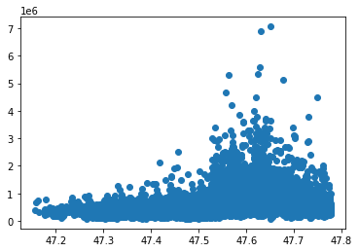

Figure : Price vs Latitude

In Figure 1, we can see how there is a small upward trend in price between the latitude values 47.5 and 47.7. This outlines a greater demand for areas that fall under those latitudes, which falls closer to the northern part of Seattle and the downtown area. When you compare this information to the map in Figure 2, we are given a clearer picture of the area we should be focusing on. We can assume that there are certain areas in Seattle which have a higher demand. This assumption is further supported by the correlation between Latitude and Price, which is at 0.31 (see Appendix Figure 9 Heatmap of Correlations), meaning that there is a somewhat strong linear relationship between the two variables.

Figure : Map - Darker is More Expensive

As we explore potential neighborhoods for house flipping, we delve into the unique features and opportunities presented in the Ballard area. This example aims to provide valuable insights into the characteristics, current trends, and promising prospects for house flipping in similar neighborhoods.

Ballard, known for its maritime history and Scandinavian heritage, has evolved into a trendy and sought-after neighborhood. Situated in the northwest part of Seattle, Ballard is characterized by a mix of historic charm and modern amenities, making it an attractive prospect for house flipping. Ballard has experienced steady appreciation in property values over the past decade. The influx of young professionals and a thriving local economy contribute to the demand for housing in this neighborhood. The commercial core of Ballard is bustling with local shops, trendy boutiques, and a diverse range of restaurants. The walkable and vibrant atmosphere adds to the appeal of the neighborhood. Additionally, Ballard benefits from accessible transportation options, including bus routes and proximity to major roadways. The Ballard Locks and waterfront areas offer additional recreational opportunities. Ballard boasts several parks, including Golden Gardens Park with its beach and scenic views. Access to green spaces enhances the neighborhood's livability. Furthermore, Ballard attracts a diverse population, including young professionals, families, and artists. Understanding the demographics is crucial for tailoring property renovations to the preferences of potential buyers. Proximity to quality schools and educational facilities is a positive factor for families considering Ballard as their residence. Given the mix of historic and newer homes, there are ample opportunities for creative renovations, from preserving historical features to adding modern amenities. The consistent demand for housing in Ballard positions it as a favorable market for house flipping.

**Addressing Inventory Issues**

As the population in the Seattle area continues to grow, the size of lots has steadily decreased over the years. However, one can still find larger lot sizes in the older neighborhoods closer to the downtown core. A growing trend in the Seattle real estate market, as well as in other major cities with similar density issues, is for developers to purchase older homes on larger lots and demolish them to build either a larger single-family home or a multiplex building that can accommodate multiple households in the space of one. This strategy is a means of increasing the value of properties, as well as increasing the inventory number of homes in areas where both housing and lots are scarce.

Figure : Price vs. Square Footage of Lot

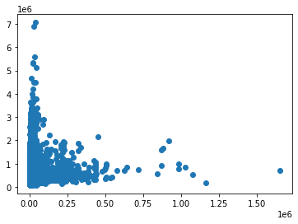

Based on the graph above, we can conclude that lot size has little to no impact on the price of a property. Properties with lot sizes under 250,000 sq. ft. show a wide range of prices, indicating that current buyers are less likely to consider lot size as a decisive factor. This assumption is further supported by the correlation between lot square footage and price, which is close to zero at 0.09 (see appendix Figure 9). Therefore, we can safely assume that there is no linear relationship between square footage and price.

Buyers often do not consider the lot size when making a property purchase. Therefore, we need to focus on other factors that affect the property's value to buyers. One such factor is the livable square footage of the homes. To maximize profits, we can find the optimal square footage of the properties while still fitting as many properties as possible on a single lot.

**Maximizing Floor Space and Leveraging Property Grade**

Our strategic focus on maximizing floor space (sqft_living) and leveraging property grade is substantiated by robust data-driven justifications. The correlation between house prices and square footage is visually evident in Figure 4, where a compelling narrative is painted. The heatmap (See Appendix Figure 9) reinforces this correlation, establishing sqft_living as a pivotal variable in our strategy. Further validation comes from the XGB Regressor Model (Figure 5), which assigns a high level of importance to sqft_living, solidifying its role in predicting home prices.

Figure : Price vs Square Footage

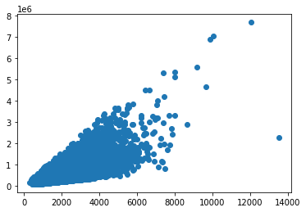

Figure : XGB Regressor Model - 80% Test Accuracy

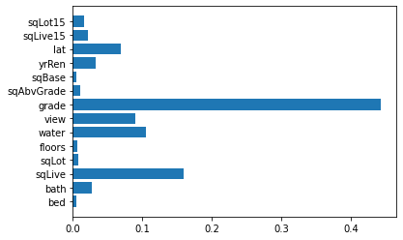

Figure : Decision Tree Model - 67% Test Accuracy

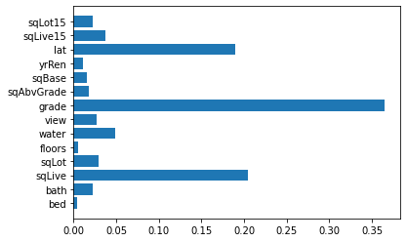

Similarly, property grade emerges as a significant factor influencing home prices, as highlighted in the correlation heatmap (Appendix Figure 9). This visual cue is further supported by both the Decision Tree Model (Figure 6) and The XGB Regressor Model (Figure 5), both of which substantiate the importance of grade in predicting home prices. The synthesis of these data-based justifications unequivocally supports our strategic focus on maximizing floor space and leveraging property grade. The positive correlation between square footage and home prices, reinforced by both visual representation and model outputs, aligns seamlessly with our goal of maximizing profits through house flipping. Likewise, the importance of property grade, as highlighted by various models, reaffirms its critical role in influencing home prices, providing a robust foundation for our strategy.

In the meticulous execution of our house flipping strategy, we prioritize practical considerations as integral to our success. Collaborating closely with seasoned architectural experts is fundamental to our process, leveraging their insights to discern untapped potential in properties, including basements or expansive yards. Regular consultations and on-site visits facilitate a continuous exchange of ideas, aligning our property selection with strategic objectives. Our proactive engagement with local authorities ensures a comprehensive understanding of zoning laws, securing permits, and maintaining legal compliance, forming a seamless foundation for our expansion plans. Combining predictive analytics with practical property selection, renovation, and market timing, our strategy aims to maximize profits in a data-driven and systematic manner. Simultaneously, our emphasis on optimal property selection involves leveraging the discerning eye of architectural experts to identify untapped potential, forming the bedrock for our strategic approach. The meticulous elevation of property grades, prioritizing high-impact renovations and a focus on expanding living space, aligns with our commitment to innovation and quality, adhering strictly to local building codes. Our market approach strategically targets growth neighborhoods through meticulous data analysis, ensuring financial readiness to navigate cyclical market patterns and minimizing risks in our dynamic market endeavors.

**Justifying Property Value**

When we look to redevelop and flip houses, one of our main goals is directing the energy towards the properties that will get us the most return on our investments. Two key facilities are important when considering buying and flipping property, and those are: the number of bedrooms and the number of bathrooms a property has. These are valuable because the number of bedrooms and bathrooms will help to determine how many residents/tenants can stay in the house. In the context of house flipping, the number of bedrooms and bathrooms can significantly impact the property's value and its appeal to potential buyers. The ideal bedroom and bathroom ratio can also vary based on the target market and location. Here are some key points to consider:

* **Market Demand:** Understanding the local market demand is crucial. In some areas, a higher number of bedrooms may be more attractive to families, while in others, a smaller number of bedrooms with more living space might be desirable.
* **Family-Friendly Features:** In family-oriented areas, houses with more bedrooms and sufficient bathrooms tend to be more attractive. Families often prefer homes with separate bedrooms for children and adequate bathroom facilities.
* **Demographic Trends:** Consider the demographics of the potential buyer pool. For example, if your target market includes young professionals or singles, a smaller house with fewer bedrooms but modern amenities might be more appealing.
* **Investment and Return (ROI):** House flippers need to consider their investment and the potential return on that investment. Adding bedrooms or bathrooms can increase the property's value, but it is essential to balance the cost of renovation with the expected increase in selling price.

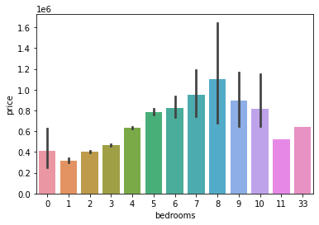 Successful house flipping requires a combination of market knowledge, financial acumen, effective project management, and a keen eye for property potential. Staying informed, making strategic decisions, and adapting to market conditions are key elements of a successful house-flipping venture. These are some overarching factors that are essential for a company to consider before stepping forth and flipping a property. Due to the enormous amount of financials that are poured into house flipping, we need to understand if the flip is worth it in the end. We cannot proceed without all the relevant information. Below are some further in-depth considerations that are essential to consider when we look at a property’s value:

Figure 7: Price vs Number of Bedrooms

**Bedrooms:**

* **More Bedrooms**: Generally, houses with more bedrooms tend to have a higher market value, especially if they cater to the needs of larger families. Larger homes with multiple bedrooms are often valued higher than smaller ones.
* **Flexibility:** Additional bedrooms offer flexibility for various purposes, such as guest rooms, home offices, or workout spaces, which can increase the overall appeal of the house.

**Bathrooms:**

* **Master Suites:** Houses with master suites, including attached bathrooms, are often considered more luxurious and can command a higher price. Buyers often appreciate the convenience and privacy of having a bathroom attached to the master bedroom.
* **Ratio:**The ideal number of bathrooms varies, but a good rule of thumb is to have at least one bathroom for every two bedrooms. Insufficient bathrooms relative to bedrooms can be a drawback.

Figure : Price vs Number of Bathrooms

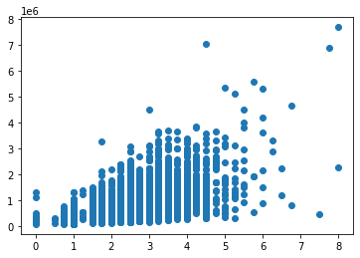

Understanding the interwoven influences of these factors is greatly beneficial to the company before it decides if a property is worth flipping. As we can see provided in the Heatmap of Correlations(Appendix Figure 9). The strong positive correlation that we see between the number of bedrooms and bathrooms and vice versa can indicate to us that these values are dependent on each other and as one increases so does the other, or vice versa with a decrease in either. In the context of real estate, this correlation could suggest certain trends or preferences in housing design and construction as mentioned above when considering demographics of residents such as families vs working professionals.

**Conclusion**

Our strategic approach to house flipping in the dynamic Seattle real estate market revolves around harnessing the strong demand for housing against a limited supply. This report serves as a comprehensive guide, emphasizing not only the financial soundness of properties but also the strategic enhancement of their housing capacity. Regardless of the original state of the property, if we were to follow the overall strategy, we will overall have a profitable outcome.

The importance of location cannot be overstated, and our analysis, exemplified by the exploration of Ballard, highlights the significance of well-established amenities, accessibility, and community connectivity. By strategically selecting locations undergoing redevelopment, we aim to redefine the urban development landscape, contributing to sustainable growth in evolving communities.

Addressing inventory issues, we recognize the trend of demolishing older homes on larger lots to increase property values and the inventory of homes in scarce areas. Our data-driven analysis reveals that lot size has little impact on property prices, prompting a focus on other factors such as livable square footage to maximize profits.

The strategic focus on maximizing floor space and leveraging property grade is substantiated by robust data correlations. The synthesis of visual representations and predictive models supports our commitment to a systematic and data-driven approach, aligning seamlessly with our goal of maximizing profits through house flipping.

The meticulous execution of our strategy involves collaborating with architectural experts, engaging with local authorities, and balancing predictive analytics with practical property selection and renovation. By targeting growth neighborhoods, we ensure financial readiness to navigate market patterns and minimize risks.

Justifying property value revolves around understanding market demand, demographic trends, and the investment-to-return ratio. The correlation between the number of bedrooms and bathrooms, supported by our data analysis, offers valuable insights into housing design preferences based on demographics.

In the intricate interplay of market forces and property characteristics, our strategy unfolds as a roadmap to success in the art of house flipping, tailored for the unique challenges and opportunities presented by the Seattle housing market. This report is more than a document; it is a strategic guide to unlocking untapped opportunities and driving sustainable growth in the ever-evolving landscape of urban development in Seattle.

Appendix:

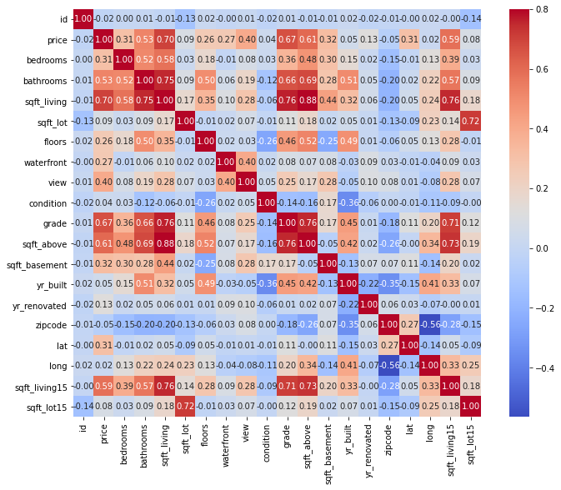

Figure : Heatmap of Correlations